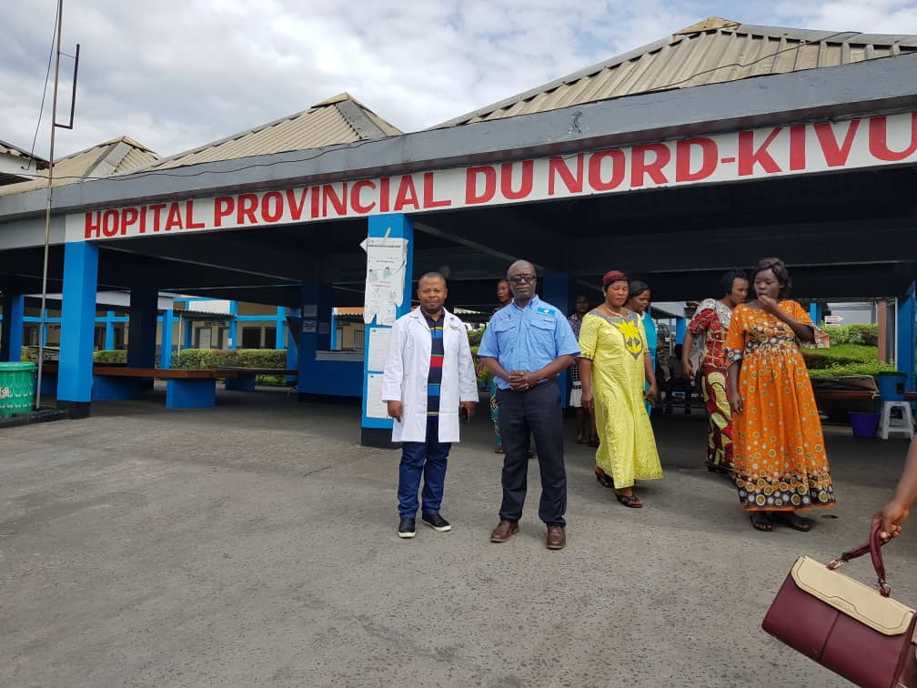
Dr Jean Claude of Helping Hand for Survivors’(HHS) traveled to the Democratic Republic of Congo on April 30th, 2019. Once in Bukavu, which is where HHS is headquartered, he spent a week awaiting the equipment to arrive in the neighboring town of Goma. During that time, he jumped into working on the mission, which was to support other organizations in place to fight the Ebola virus and to provide clean water to the population of South Kivu. Immediately, he began by contacting local medical professionals and leaders to set up meetings to educate them on how the equipment works.

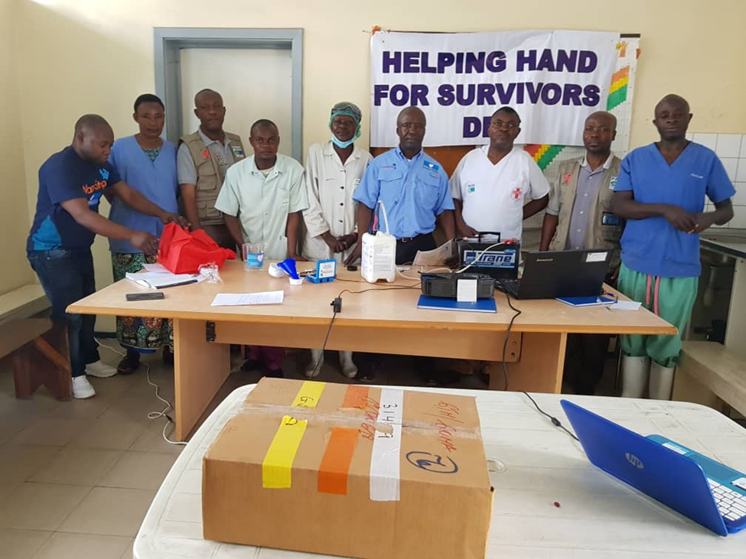

During second week, Dr. Jean Claude delivered the equipment and trained medical professionals in the cities of Goma and Bukavu including doctors and nurses.
Jean Claude traveled to the DRC to train doctors and other medical professionals on the WaterStep equipment. While there, he was able to distribute BleachMakers and M-100 Chlorine Generators to several medical clinics throughout the DRC. Disinfection and using safe water during medical procedures are key in stopping the spread of the Ebola virus. We hope that the community will take advantage of this equipment to access a better life because water is life and there is no life without water.

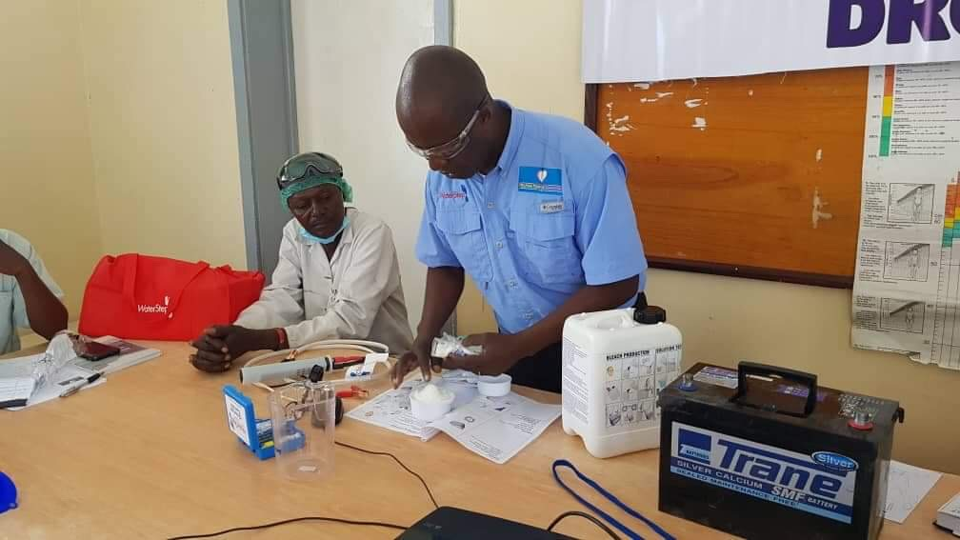

Helping Hand for Survivors is grateful for the opportunity to partner with Waterstep to stop the spread of Ebola in North and South-Kivu of DRC and to provide access to safe water and disinfectant to the Survivors in these regions. HHS Health Project Manager Dr. Jean Claude has trained our staff and partners in Goma as well as in Bukavu on how to respond in case of an Ebola outbreak. Dr. Jean Claude distributed materials and conducted a training session on the Bleach Maker for medical professionals. Now that the first Ebola case was confirmed in Goma, we ask the population to follow the advice provided by our staff and healthcare workers.

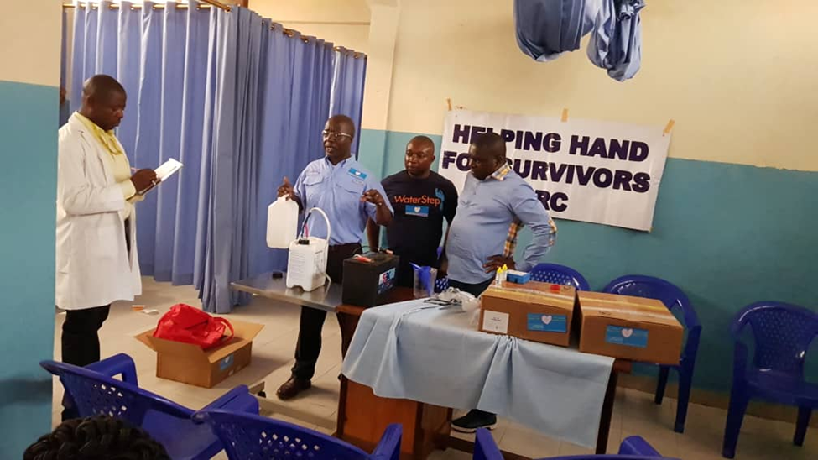

These Bleach Makers were designed by the WaterStep manufacturing team in direct response to the Ebola outbreak in West Africa in 2014. The bleach produced by these machines exceeds the World Health Organization standards, which is at 5 PPM to be used in a medical clinic and is strong enough to kill the highly contagious Ebola virus. It was our goal of Helping Hand for Survivors to step in to help with the Ebola outbreak before it breaks out in big cities and to ensure the making the bleach makers are available when needed.

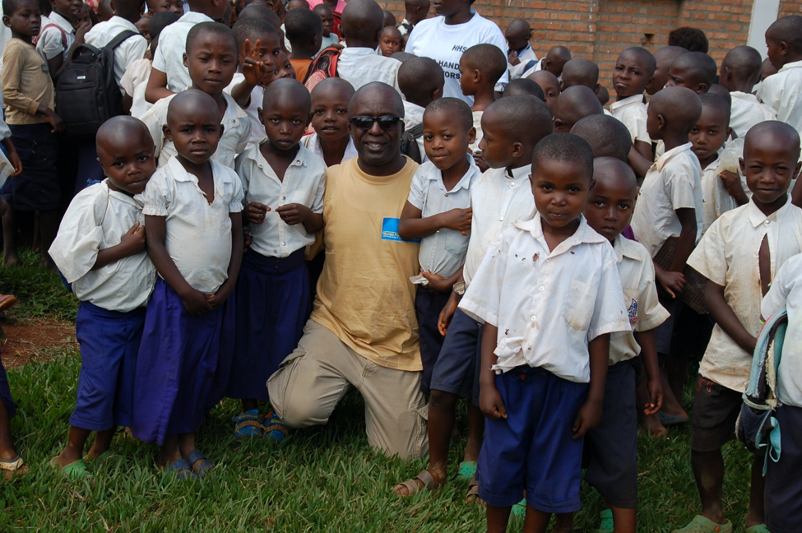
Jean Claude also visited several people within his organization, Helping Hands for Survivors. The mission of Helping Hands for Survivors is to aid, advance and support the healing and recovery of women and children surviving and living in post-conflict communities in the DRC. The organization provides shelter and support to rape victims and their children as they heal and get back on their feet. Our hope is that healing process will be made just a little easier with access to safe water and disinfectant; education, health care and basic needs allowing every woman to care for her family.

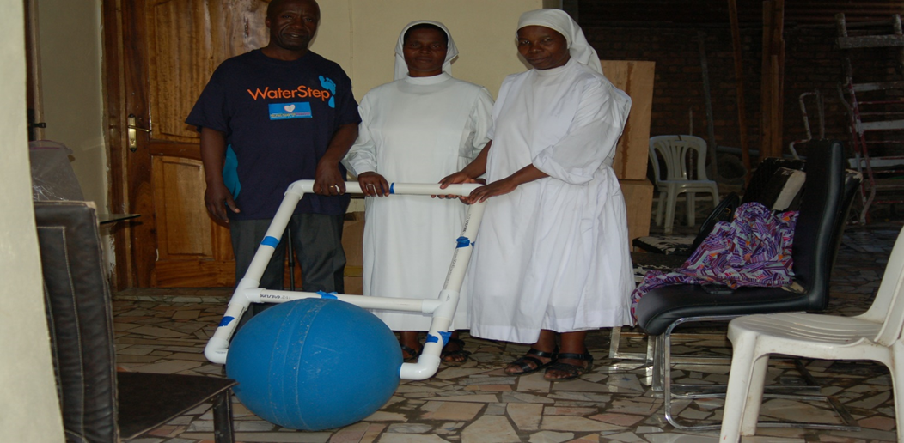

During Dr. Jean Claude’s trip, he also visited an orphanage, where he was able to give out Waterballs. Pictured here is the blue WaterBall that Helping Hands for Survivors supported some of our orphans in the town of Kalehe to help them transport water in lieu of caring gallons of water to their heads or back, which can cause damage to their body and affect their growth in the future. Nun pictured with Orphans, Bacira.
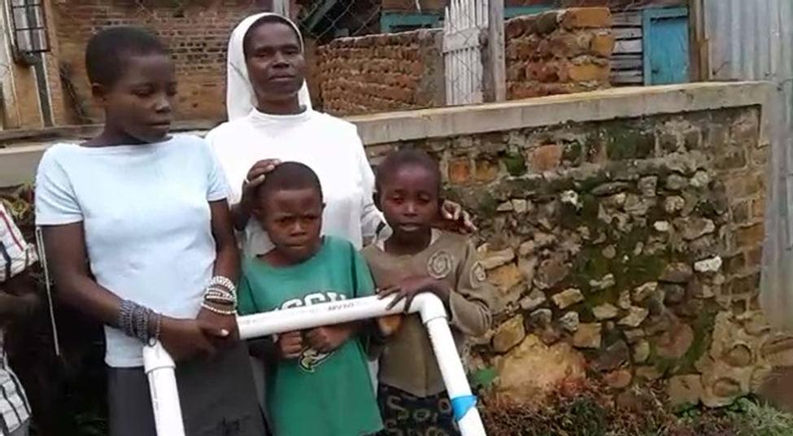
The WaterBall is a water transport tool that rolls easily over almost any surface. The average container a woman or child carries on their head to transport water holds 5 gallons and weighs 40 pounds. The five gallons will supply water to one person in the family for one day. Depending on the size of the family, the women and children may have to make multiple trips a day to get water. The WaterBall holds 12.5 gallons of water which is 2.5 times the amount they can carry on their heads. Another WaterBall was given to an elderly woman, one of our Community Leaders, to help her transport water to her house since she is unable to carry a gallon of water on her head or back.

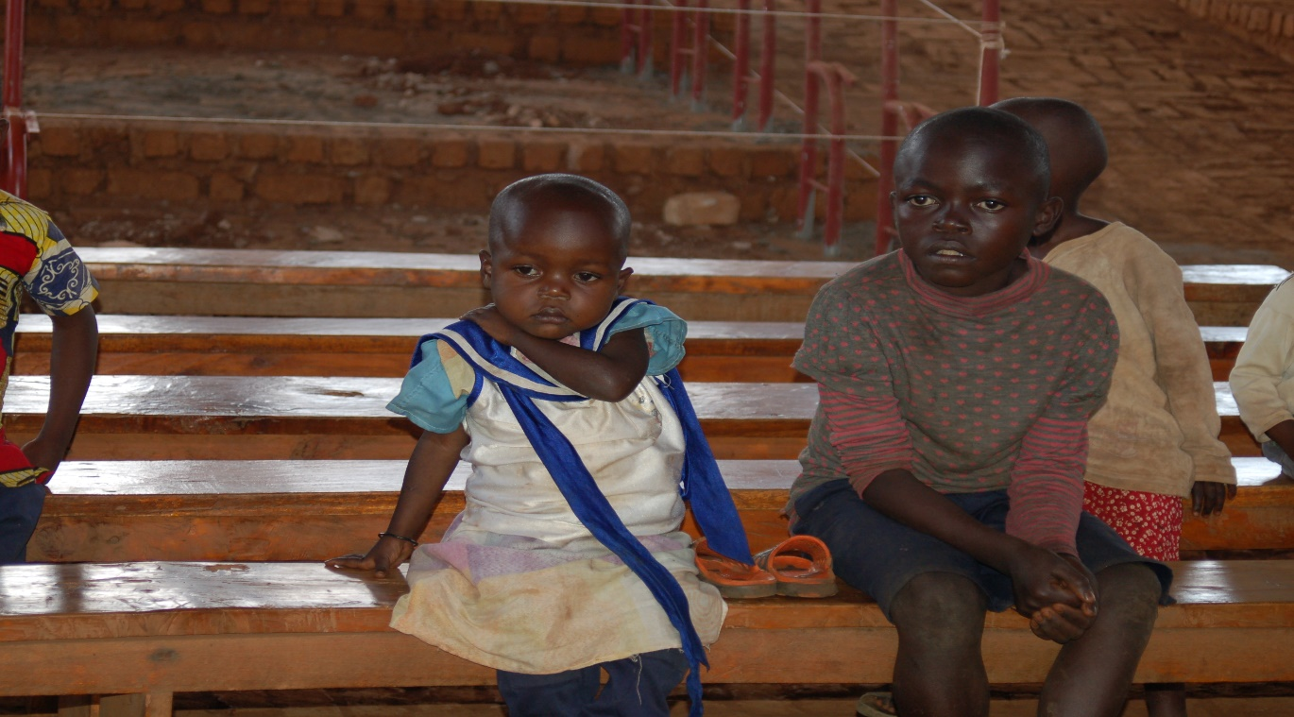
Here you can see how Dr. Jean Claude is training local healthcare professionals using the newly installed M-100 Chlorine Generator in DRC. This system will provide access to safe water and prevent the spread of waterborne diseases. Using treated water from these M-100 Chlorine Generators will prevent many people from getting contaminated by water related disease such as cholera, diarrhea, etc.
Want to donate a WaterBall to help more orphans and families like Bacira’s in this family? You can contribute on line here or by sending your donation to Helping Hand for Survivors or send a check to PO.Box 23325 Lexington, KY 40523.

