HHS REPORT 2020: OUR ACTIVITIES 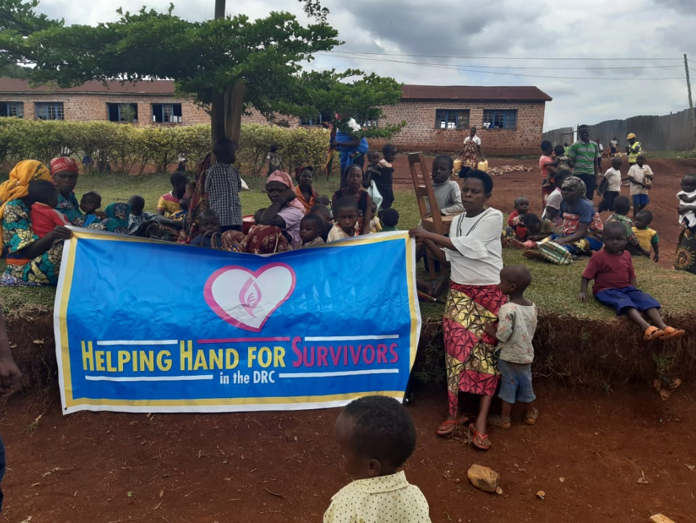
Despite COVID-19, the year 2020 was marked by several undeniable successful activities:
Health, Nutrition and WASH (Water, Sanitation, And Hygiene):
During this pandemic year, Helping Hand for Survivors has delivered more than 8 water treatment machines to different places including: Kalehe, Buzi, Bunyakiri, Uvira, Kasha, Nyatende, Mumosho, Goma, and Bukavu to provide clean water and to use for hand wash and spaces. Helping Hand for Survivors produces chlorine liquid which we are gradually teaching the population how to use safely. HHS continues to produce water bleach for water treatment to reduce waterborne disease among communities. This program operates for prevention and control measures for improving health, reducing poverty, and improving socio-economic development as well as responding to community emergencies and outbreaks of life-threatening illnesses such as cholera in area. Women in our program also use the bleach for household chores such as washing clothes and cleaning the kitchen etc. Image: 1. Demonstration and use of the M-100. 2. The production of Chlore (Bleach) 3. Use of M-100 machine training
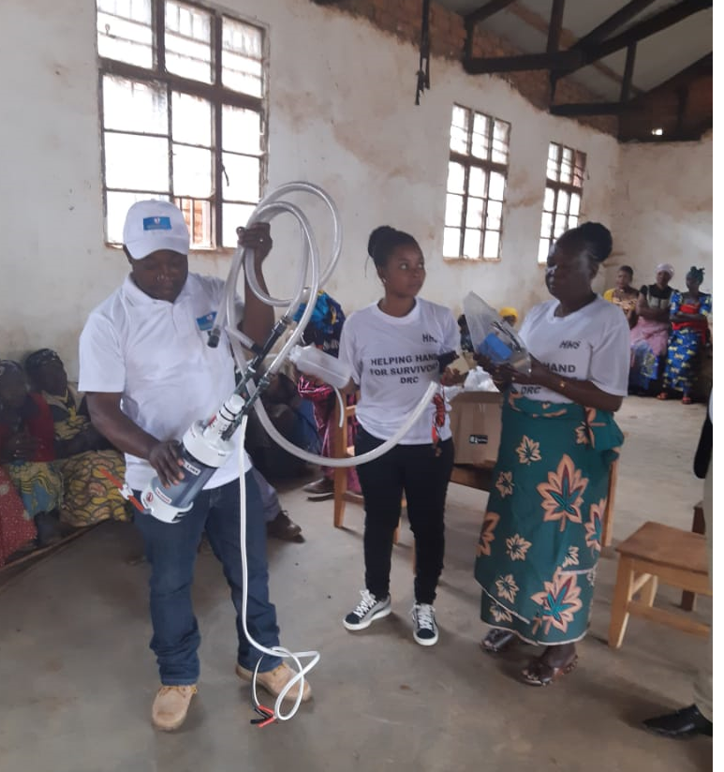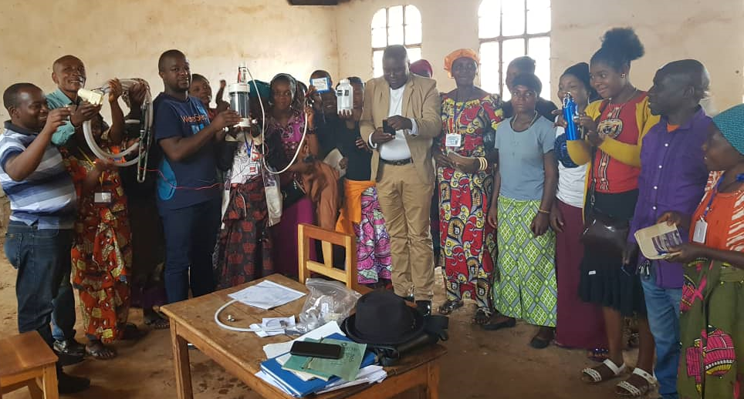
Nutrition:
Due to Covid-19 and the lack of means, HHS only made 78 percent of visits, which was not enough, but the impact of those visits should not be underestimated, especially during the confinement. Lives were saved during this hard time.
HHS served 200 malnourished children and 65 women in the territories of Kabare (Mumosho and Nyantende) during the confinement (see picture below) by educating them on the techniques that can allow them to be able to manage what little means they have and how to fight malnutrition and the pandemic. They distributed corn flour for food, Guinee pigs, the M-100 machines to clean/disinfect water and weighed the children.
We recently fed dozens of children with packets of ground corn, soy and sorghum mixed with flour. Each donation of these porridge package gives a child in the DRC essential proteins and carbohydrates. Distributing these packages to widowed mothers allows them to increase vital nutrition to their children. Two of our community leaders, Maman Anastasie and Neema Mubalama lead the HHS team on ground to successful activities during the pandemic period.
Images: 1. Distribution flour and beans 2. Children weight measurement.
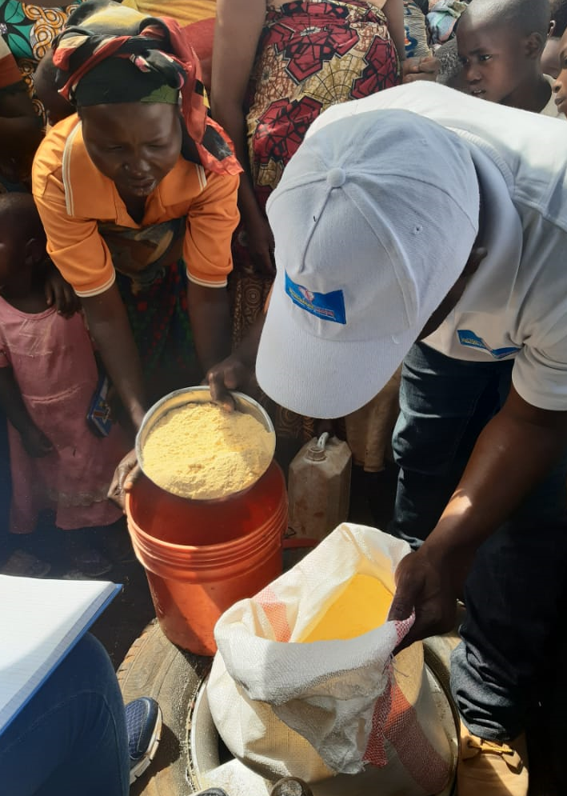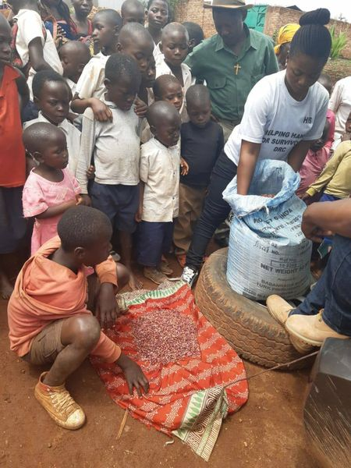
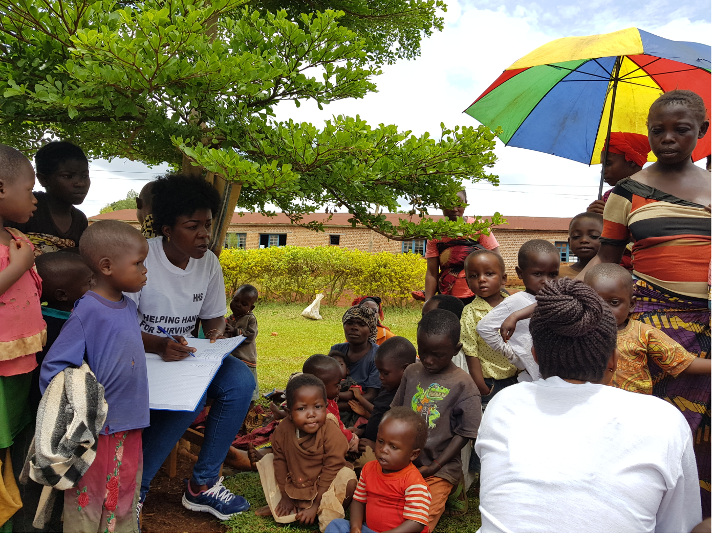
Empowering Women
Livestock component:
Helping Hand for Survivors usually distribute animals as part of the program to women, mostly widows. In 2020, more than 800 pairs of Guinea pigs were distributed to women in Mumosho and Nyatende to finally meet the nutritional needs of their families by breeding and thus rotating among women after their multiplication, which is already ongoing project in Nyatende, despite certain difficulties during the pandemic.
Pictures: 1. And 2 reception of guinea pigs by women. 3 Family photos after raising awareness
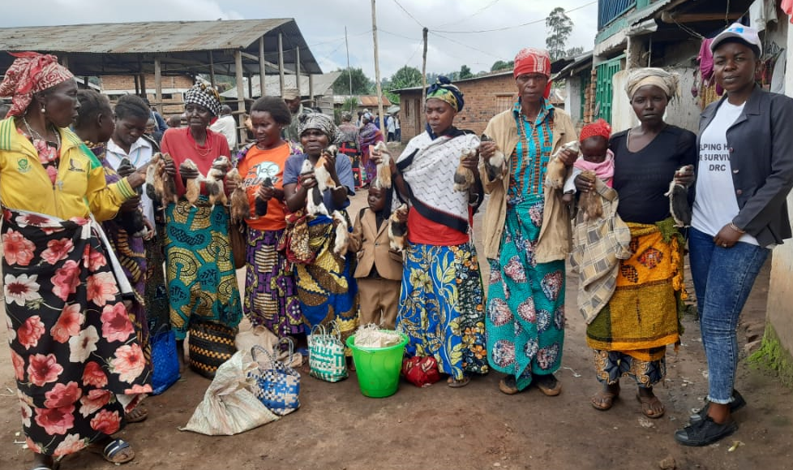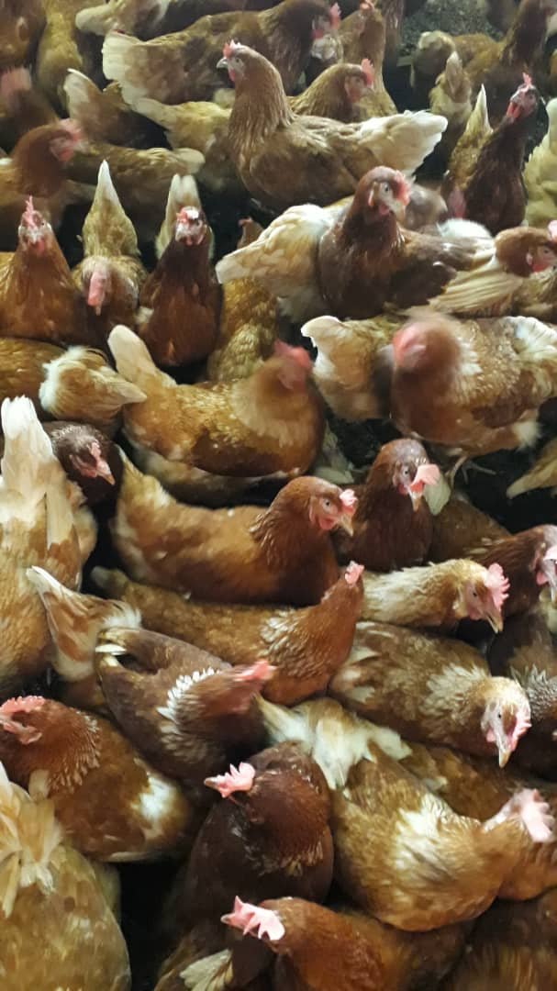
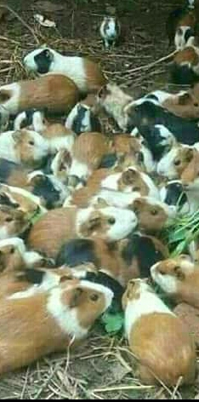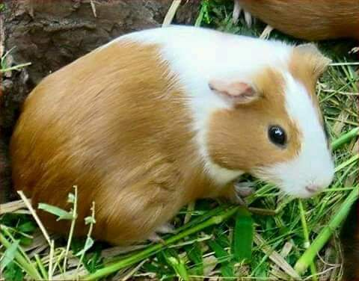

Agriculture component:
During the pandemic, HHS distributed seeds of beans and corn to the women to enable them to cultivate and reimburse a small portion of their harvest to the group, which in turn will have to be redistributed to another group of women finally to make the group autonomous and thus establish an agricultural seed cooperative and eventually become a seed producer in the area and sell on the seed at the market which is very profitable and allows women to become financially independent.
Pictures: 1. Seeds reception 2. Bean fields / Pictures: 1. Seed reception 2. Bean fields
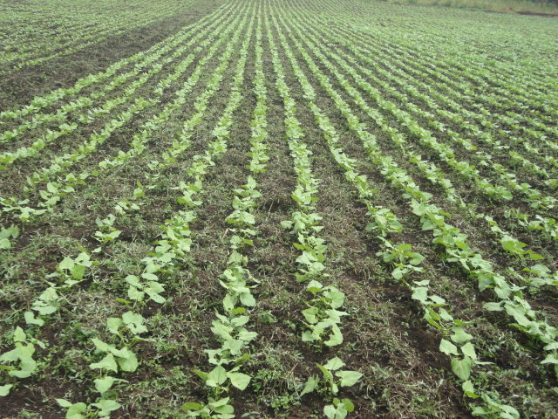
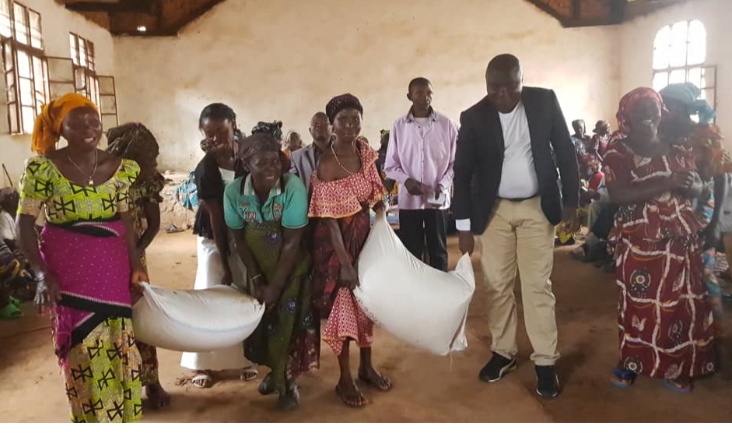
Micro-credit component:
HHS started this program with widows in Nyantende. 10 women were given a credit of $50 each to start a small business. The goal here was to support families taking care of themselves while having a supervisor based in their community. Once a beneficiary reaches a profit of $50, she must return the capital and pass it to another widow in lieu of paying it back to HHS after 3 months. The rotation has been successfully running and allowing fund to other women though the effect of the pandemic. The end of May 2020, only 7 women were able to rotate. Others were caught in the middle of the Covid-19 crisis. They could not do business. After the assessment HHS decided to continue with those who have done well, and they are now on their 4th rotation.
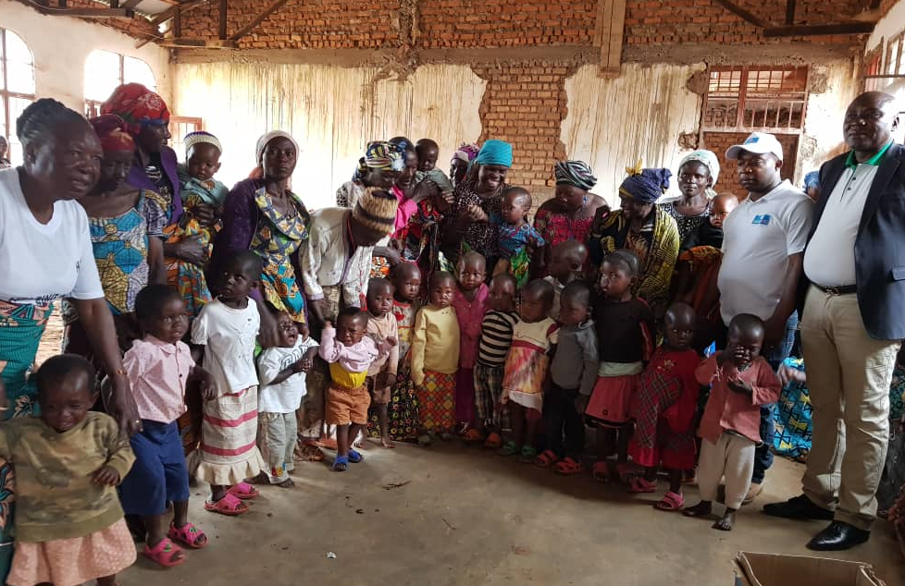
Education:
HHS is now supporting 25 orphans including 20 girls in primary school and one family of 5, 2 girls and 3 boys. For a time, we accompanied the 5 children in Kalehe with the Sisters of Kalehe supervising them. Although the DRC government has waived the school fee for elementary schools, we think that this support is still needed for survival (Food, clothing, and school kit)
In this activity we received a batch of booklets to be distributed in 2020 to schools for free, finally to allow schoolchildren, pupils, and students to have access to knowledge without difficulty and finally own a book of their own for the first time ever!
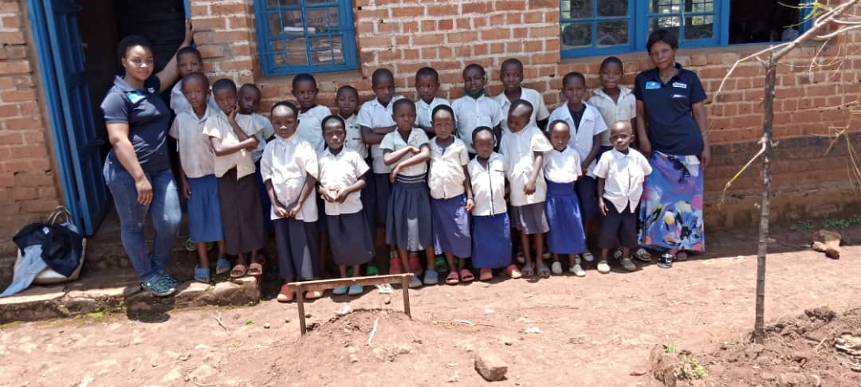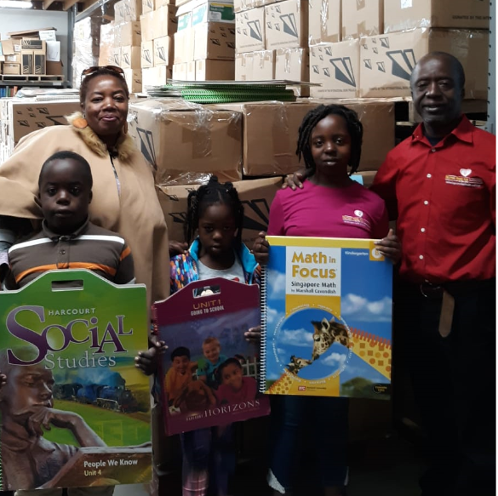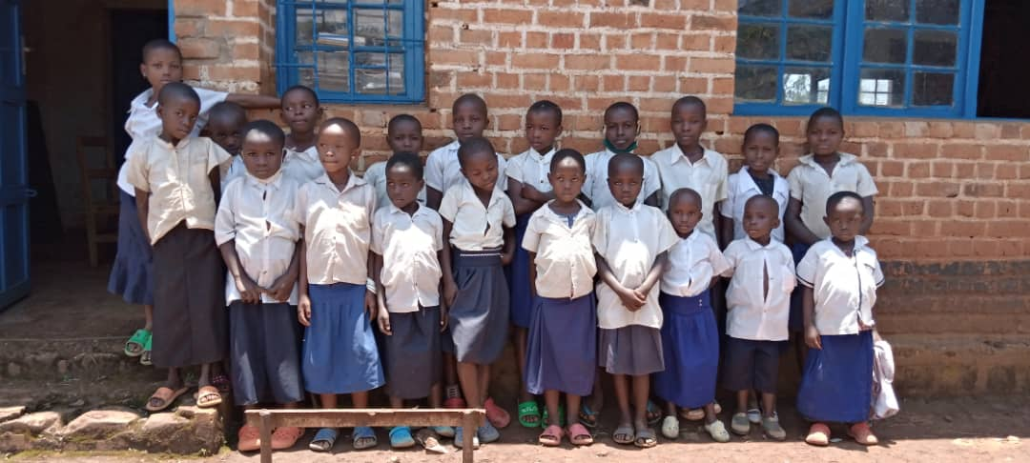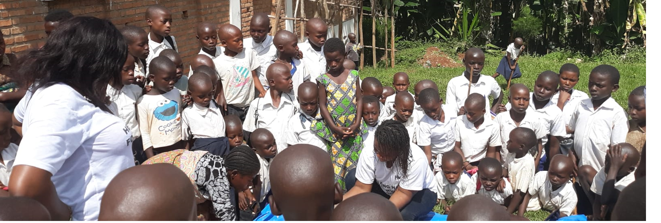

Ministry:
In addition to our implementation of physical and mental health, HHS has a spiritual ministry. Pictured in Uganda, our missionary Evangelist Rodrigue Asila (in blue shirt with long sleeves, below) with Christians. Meeting weekly for Bible Studies and fellowship, this ministry is overseen by the Helping Hand for Survivors board in Lexington, KY. With the support of HHS evangelist Rodrigue and his group, they travel house to house for Bible studies, and home visits to vulnerable refugee communities in Ugandan camps and around Kampala.
God has been using Rodrigue through this ministry to bring lost souls to Christ and his work has made a big difference in the lives of many as you can see from these photos, fulfilling Matthew 28:19, which says “ Go and make disciples of all the nations, baptizing them in the name of the Father, of the Son, and of the Holy Spirit.”
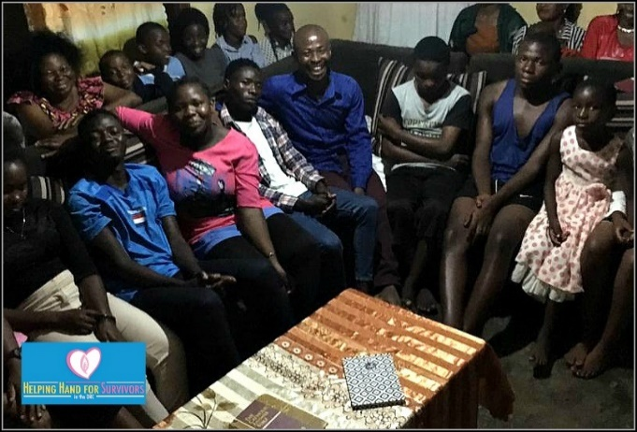
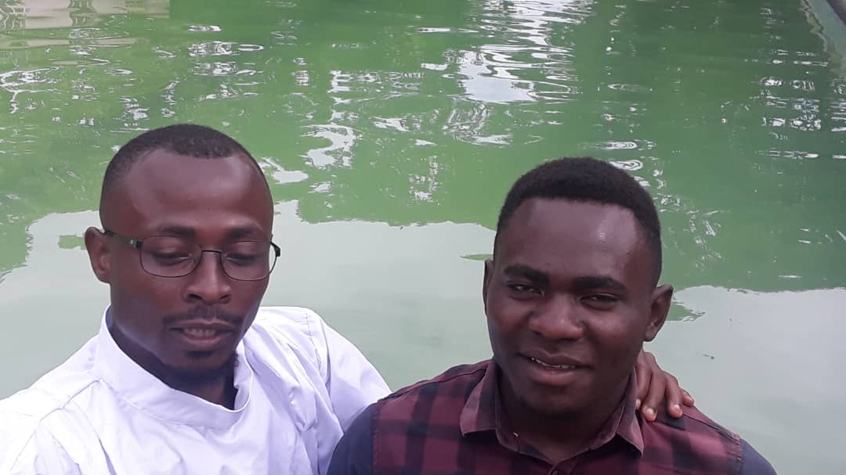

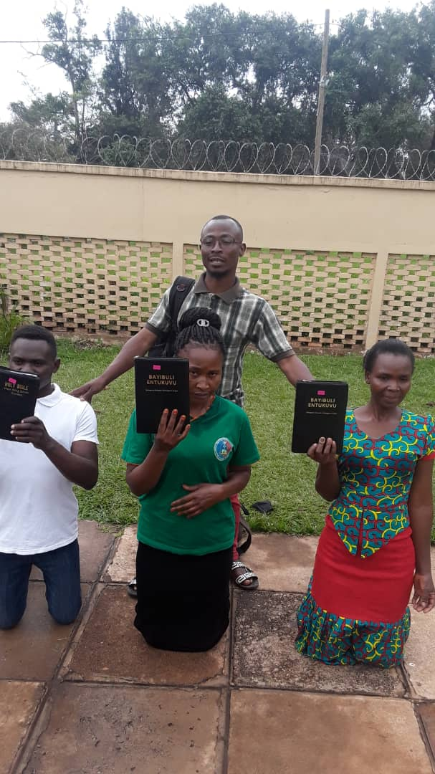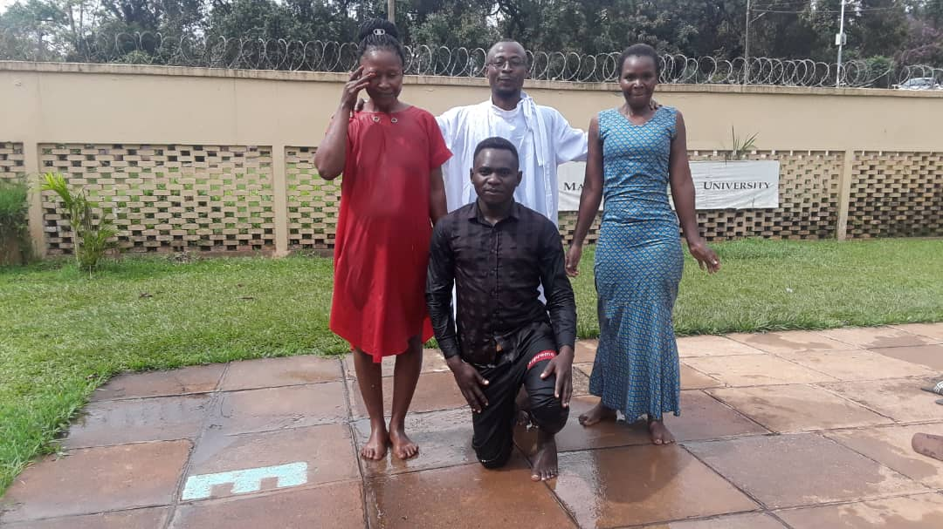Glory Be To God…

